IOSH

Development Plan

Faiyaz Sattar

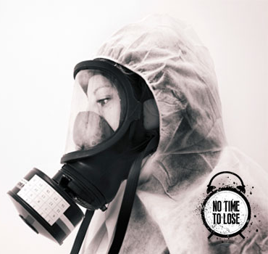

Your Development Plan

This is your IOSH development plan.
Your development plan is based on the IOSH Skills framework and provides a clear view of the competencies that you hold and those that you are intending to develop as part of your professional development.

Note: The information in this report has been self-certified and shows the individual understand the importance of the IOSH Skills Framework, recognises that they can user the IOSH Skills Framework to develop their career and capabilities, and has actively identified their next development steps.

Development Plan Summary

The following diagram shows your assessed levels and development activities for the skills in the IOSH framework.

Development Plan
You have specified the following skills and skill levels for inclusion on your Development Plan.

Further Information
You can find further information about the IOSH framework here:
http://www.iosh.co.uk/

Institution of Occupational Safety and Health
The Grange, Highfield Drive, Wigston, Leicestershire, LE18 1NN
Registered charity 1096790, VAT register number 705 3242 69, IOSH Services Limited company registration number 1816826

